Additional tools that are required, 8mm drill M8 tap and saw for cutting the 4040 extrusion

BOM
2 x M5 x 50 bolting OSSM to mounting ring
2 x M5 x 45 bolting OSSM to mounting ring
2 x knob grip M8 x 60 bolt legs to the end of the base extrusion.
12 x M6 x 20 plus 12 M6 T nuts for bolting hinge plate to the 4040 extrusion
4 x 25mm m8 washer for hinges
2 x handled clamp M8 x 70 locking levers fort the arm
1 x handled clamp M6 x 30 locking lever for the OSSM rotation
1 x M6 x 20 for bolting fixed side of OSSM mount ot the extrusion

The following parts need to be printed
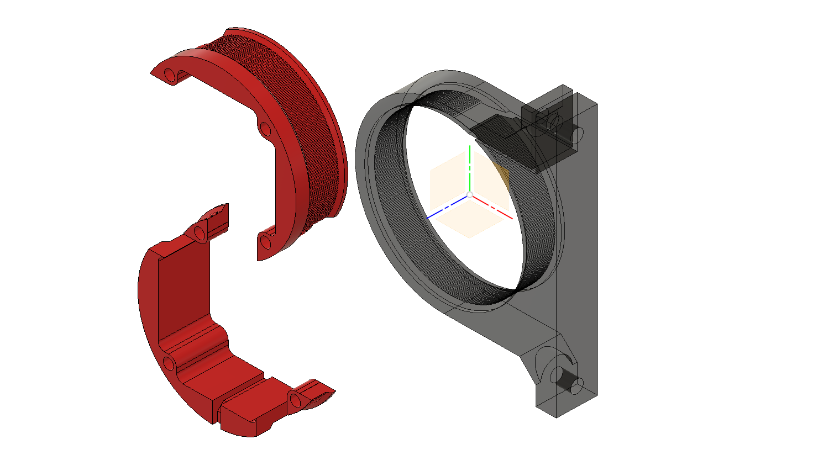X 1 motor rings and clamp
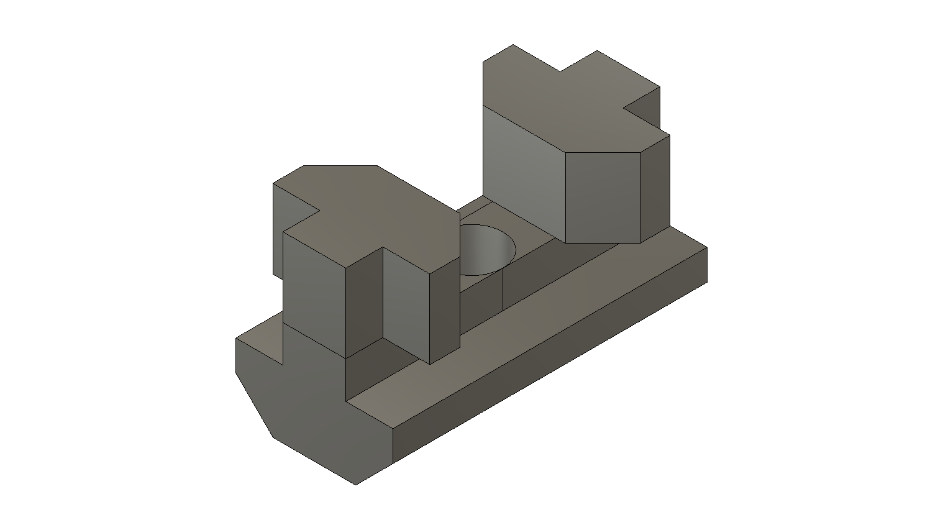X 2 leg connector
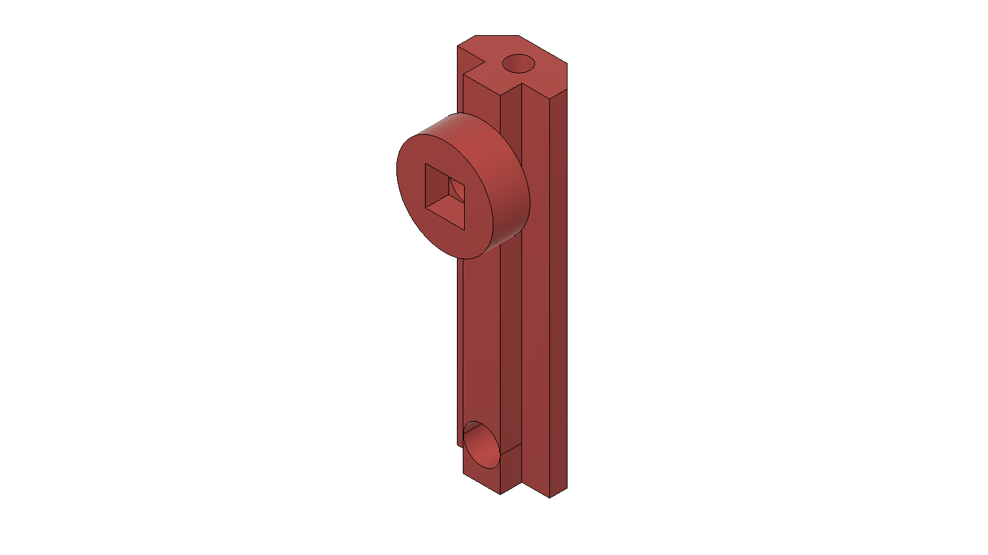X 4 or X2 with 2 of these hinges 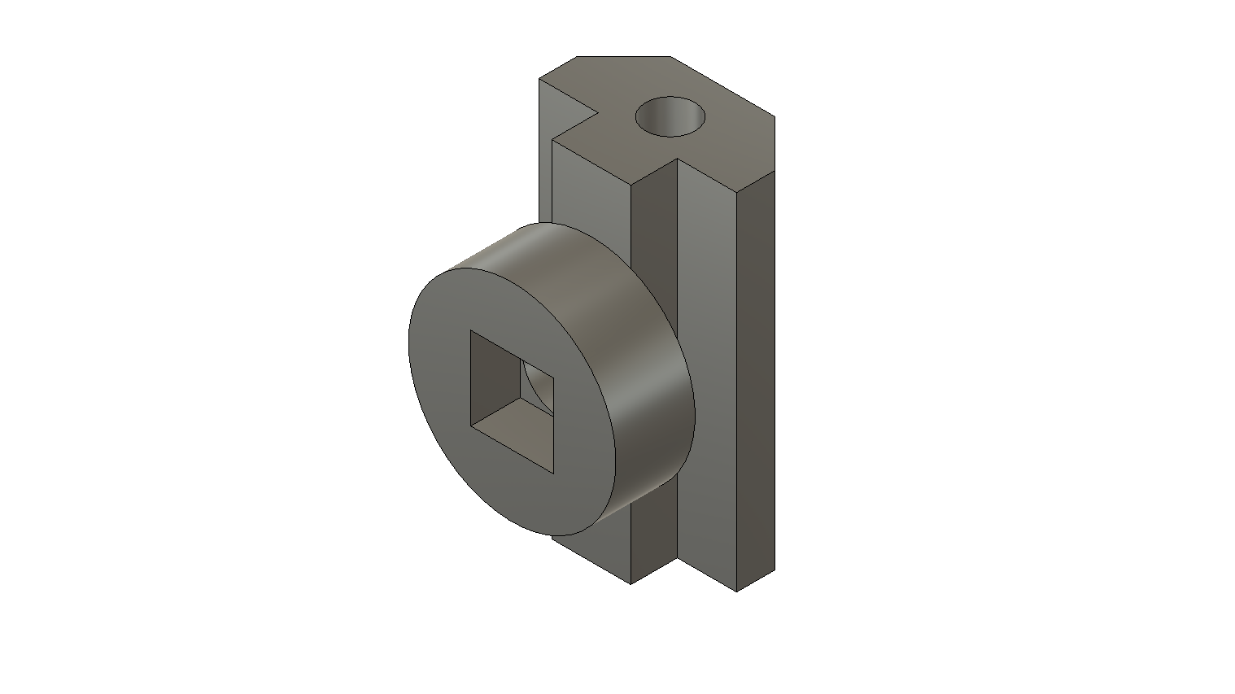
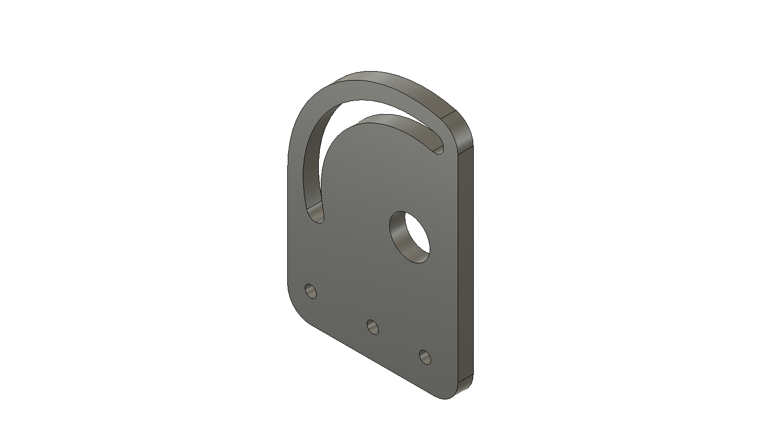 X 4 hinge plate
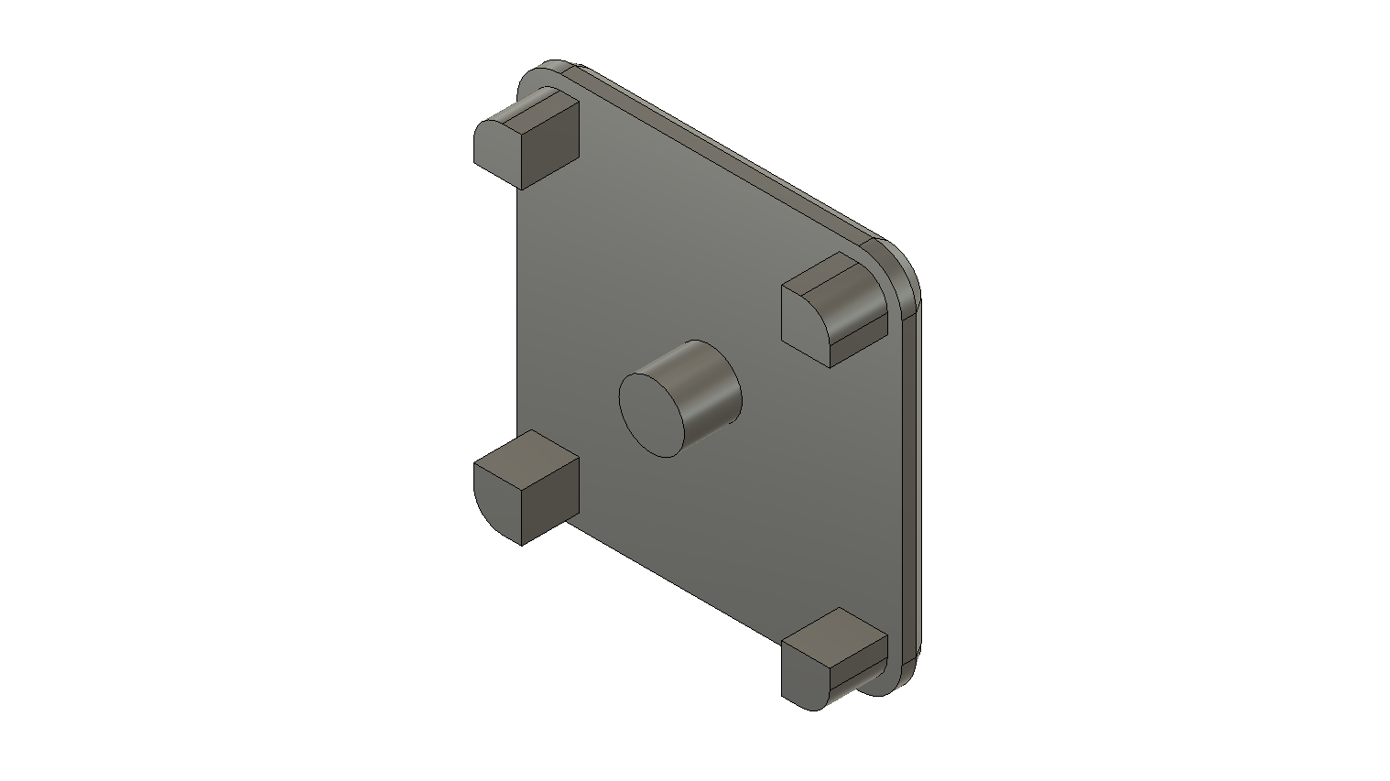X 8 end caps
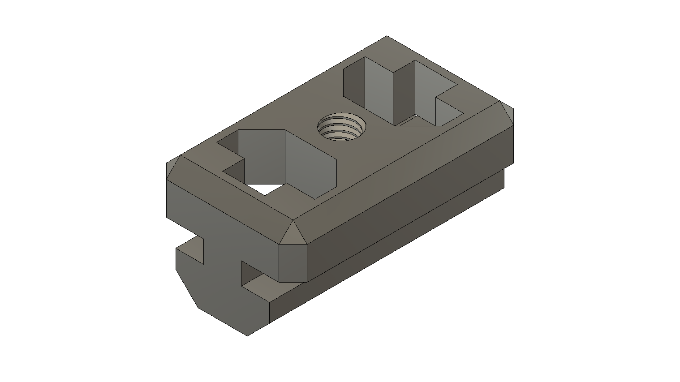 x 2 for storing the legs
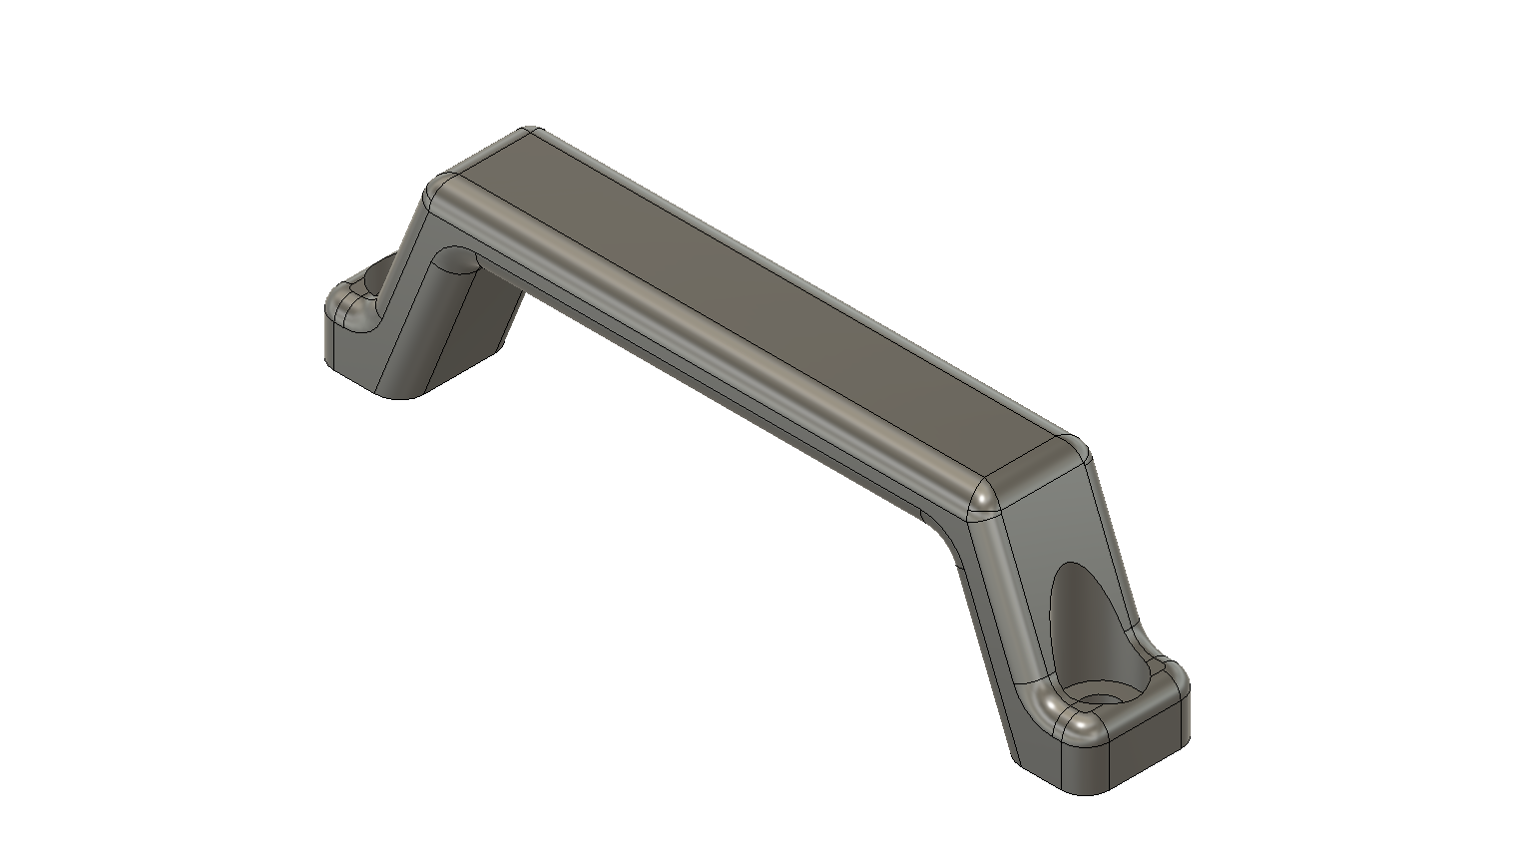carrying handle
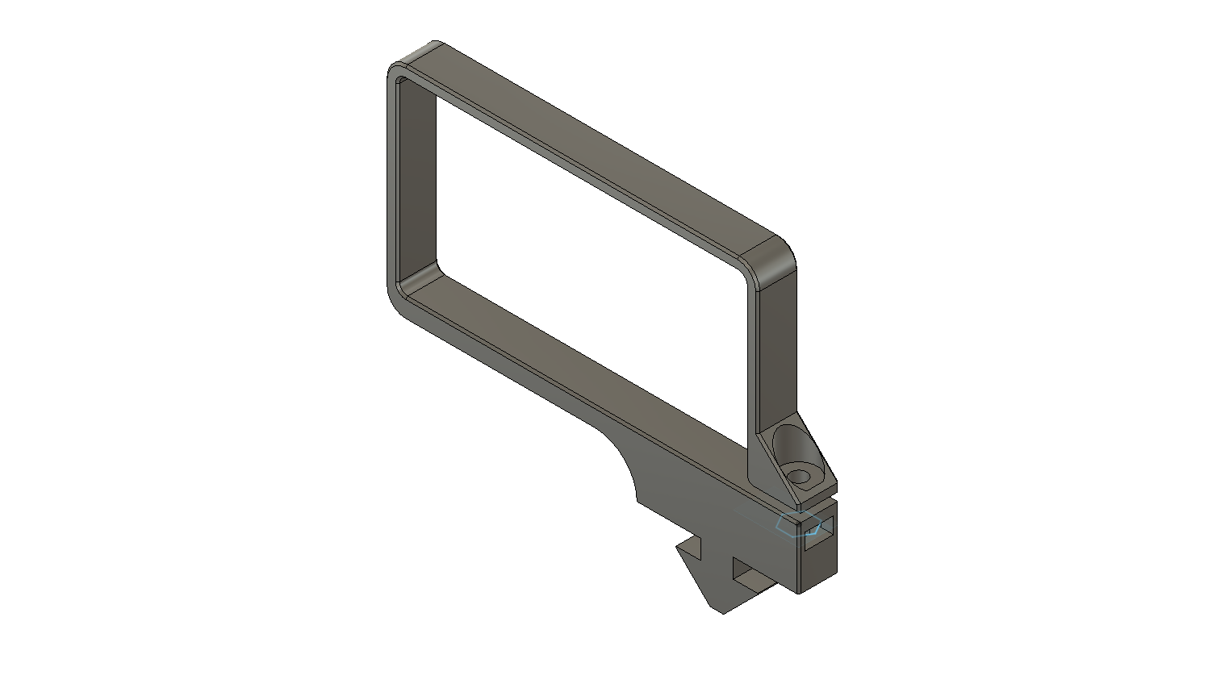x 2 for a MEAN WELL GST220A36-R7B

Assemble

Cut extrusion to length. Example 2x 400mm for legs, 3x 475 for base and arm.
Use M8 tap to tap a thread in each end of one of the extrusions for the base section.

Place a leg connector in the center of the leg and use a guide for drilling the 8mm hole through the center of the extrusion.
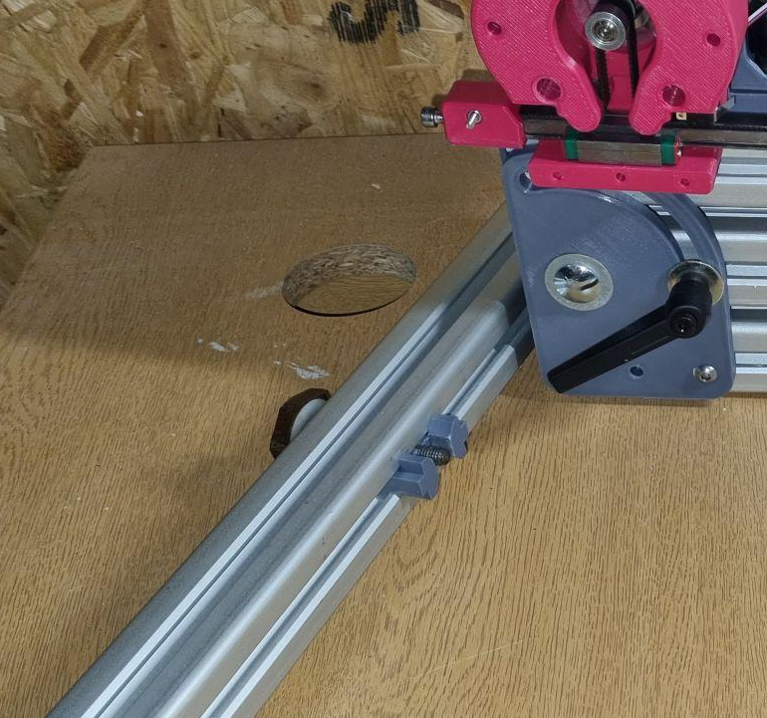
For drilling the holes on the arms insert the long hinge so that the pivot point end is flush with the end of the 4040. Drill 8mm holes through the 4040 using the holes on the insert as a guide. Its easer to drill half way through from one side and then drill though from the other side using the insert as a guide.

The hinge is first assembled by attaching the the 2 plates onto the hinge insert with a M8 bolt and a 25mm washer weather side. The clamp lever can also be attached with a t-nut as shown below. Then the M6 bolt and t-nuts are installed before being slide onto the lower section of 4040.
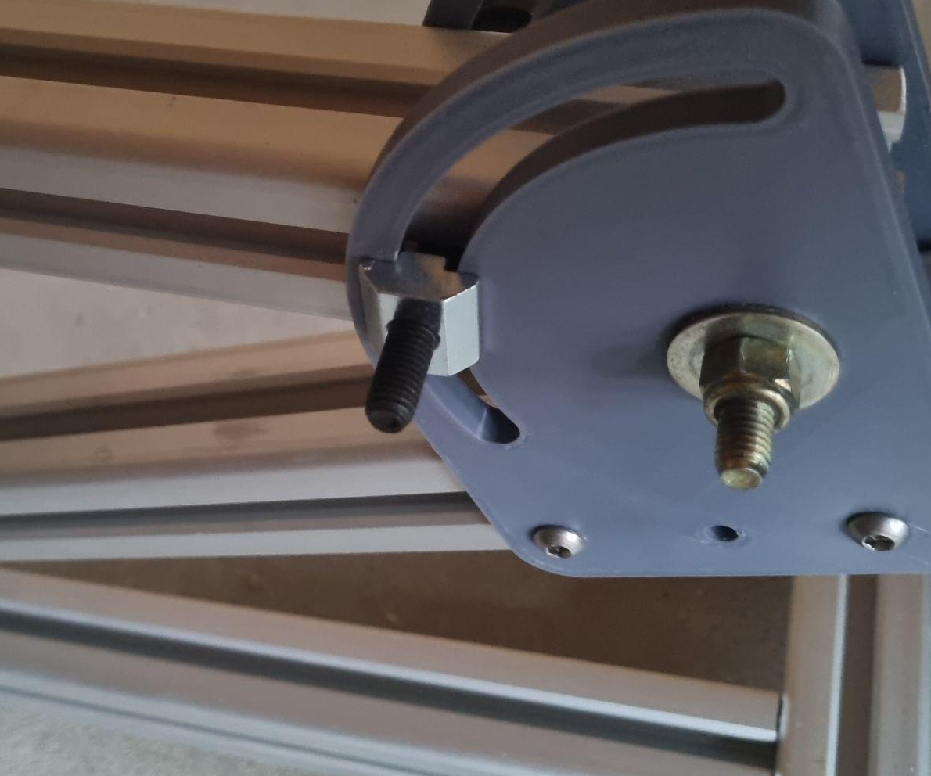
The hinge inserts have designed to accept a M8 coach bolt if needed.